1-g

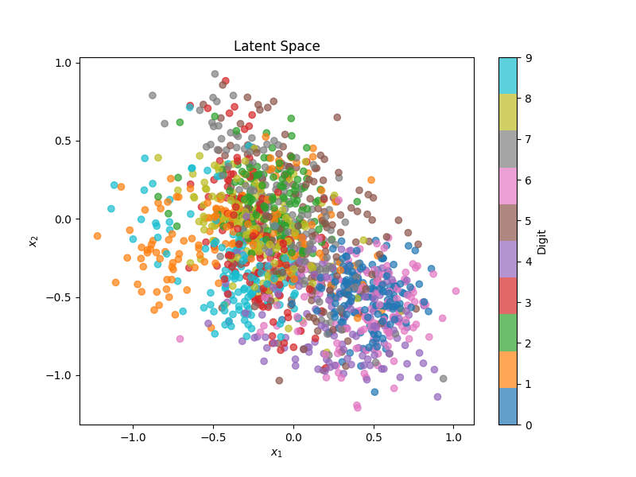

The plot shows the latent space of the digits dataset, where each point represents a digit, and different colors indicate different digit classes. Most points cluster around the center, meaning the model compresses most digit features into this central area. Although there are some small clusters, the significant overlap of colors suggests that the model struggles to clearly separate different digit classes. Overall, the model captures some features but needs improvement in distinctly differentiating between the digits.

Improvement：

①Improve the training process: train more epochs, use early stopping to prevent overfitting.

②Apply regularisation techniques: use dropout, L2 regularisation or batch normalisation.

③Improve data preprocessing: standardise or normalise input data.

1-h

